Purpose
This lab introduces the student to the Allen-Bradley MicroLogix 1400 programmable logic controller.

Objective

After completing this exercise, the student will be able to:
a) Identify major components of the programmable controller
b) Create a wiring diagram of the Input & Output section of the control
c) Explain how an Emergency Stop circuit works and why it is necessary
d) Draw an Emergency Stop circuit for the MicroLogix 1400

References
Cox, Technicians guide to Programmable Controllers, Ch2
Allen-Bradley, Bulletin 1766 Operator's Manual

Materials Needed

Allen-Bradley MicroLogix 1400 programmable controller with simulator
Graph paper and drafting equipment

Lab Procedures

1. With power on to the MicroLogix 1400, locate the following components:
a) Master power toggle-switch on the lab board.
b) MicroLogix 1400 Controller

2. On the controller module, locate the following components:
a) DC power status indicator LED.
b) Run LED.
c) Processor fault LED.
d) Force LED.
e) 9 pin male D-Shell serial port.
f) Mini-Din serial port.
g) Ethernet RJ-45 port.
h) Incoming line wiring terminals (bottom left).
i) Wiring terminals for 20 inputs (top).
j) Wiring terminals for 12 outputs (bottom right).
k) LCD display screen.
l) LCD navigation button, up, down, left and right arrows.
m) LCD Esc (Escape) button.
n) LCD Ok button.

3. With the power on, monitor the LCD display while toggling the simulator switches to see what inputs are going on and off, complete the Input wiring diagram below using the proper electrical symbols.

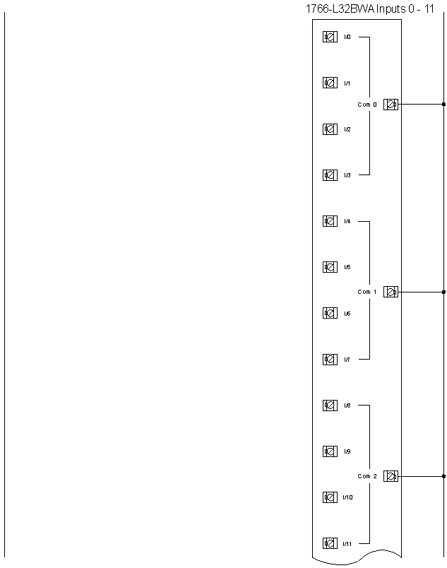
Q1.

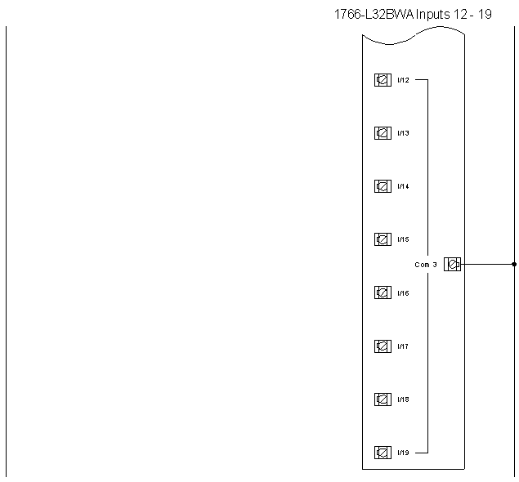

4. Notice that the 10 toggle switches on the simulator are maintained in one direction and momentary in the other direction. This comes in handy when you’re simulating a programs operation.

5. What is the status of the Power LED?
Q2.

____________________________________________________________

6. What is the status of the Run LED?
Q3.

______________________________________________________________________

7. What is the status of the Fault LED?
Q4.

______________________________________________________________________

8. What is the status of the Force LED?
Q5.

______________________________________________________________________

9. Locate the Catalog number of the MicroLogix 1400 and log in the space below.
Q6.

______________________________________________________________________

10. Press the ESC button on the MicroLogix 1400 and the LCD display should show a right arrow pointing to I/O Status. The up and down arrow button can now be used to move to a different selection. Press the down arrow until the right arrow on the display lines up with Mode Switch. Press the OK button and the right arrow on the display will be pointing to the current mode the controller is in. Log that setting below.
Q7.

______________________________________________________________________

10. Using the up and down arrow button move the pointer to the Program selection and notice the word Program is flashing. This means you are ready to change the mode of the controller. Press the OK button and notice the word Program is no longer flashing. What is the status of the Run LED now?
Q8.

______________________________________________________________________

11. Use the buttons to navigate to the pointer to the Run selection and put the controller in the Run mode. Notice the Run LED is back on. We will be using RSLogix 500 software to program our controller later we will want to be able to change modes from that software program. To do the controller has to be in Remote mode, so use the navigation buttons to select that mode. Notice the Run LED is still on. It just means that the mode can now be changed remotely from RSLogix 500 software. Use the navigation buttons to move back to the I/O Status display and view it.

12. There are 10 green pilot lights wired to the first 10 outputs. Using the proper electrical symbols, complete the Output wiring diagram
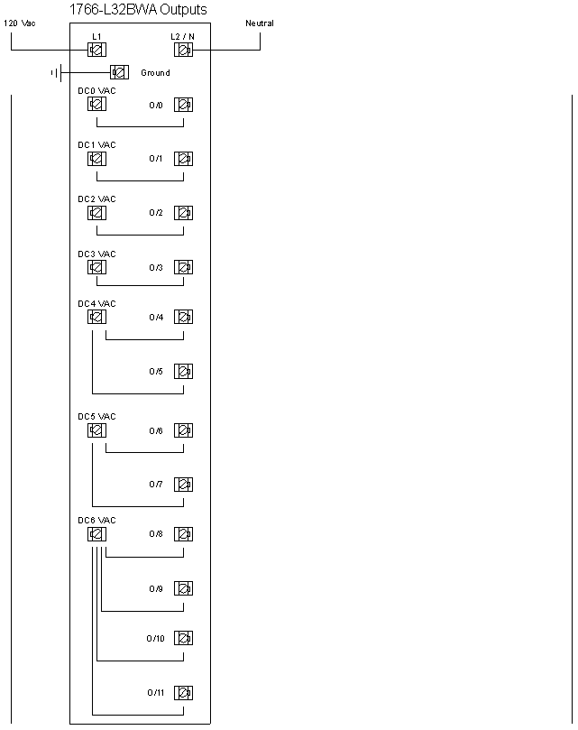
Q9.

This drawing shows how the outputs on our simulators are laid out. L1 and L2 terminals are where line power is brought in which in our case is 120 Vac. The DC \ VAC terminals are Common terminals is where power is brought in for a particular output. Note that some of these commons are shared with more than just one output. This allows you to use different power sources or voltages in the design of your control system. Since PLC’s use electronic gates to trigger the outputs we have an important characteristic to consider. Electronic gates tend to fail in an on condition as often as they fail in an off condition. This can be a big safety issue if we don’t take that into consideration when designing a control system.

One way of dealing with a problem like that or some other condition that you wanted to stop the system for would be to shut the power down to the controller but if you do that then you can’t go online with the processor for troubleshooting. Instead we need to design a circuit that will take the power away from all of the outputs but keep the inputs active so we can go online with the processor to see what is and isn’t working. The common terminals mentioned earlier come in very handy for this. If we used a relay to interrupt the power going to all of the common terminals then even if an output gate has failed in the on condition power will still be off to whatever device is wired to it.

Such a circuit is called a safety circuit or an emergency stop circuit. In the circuit below an Emergency Stop Relay (ESR) is used to accomplish this. Since we want to keep the processor powered up for troubleshooting it’s important to let it know the status of the ESR so one of the ESR’s contacts is wired as an input to the controller.

Study the wiring diagram on the next page, and then complete the questions following.

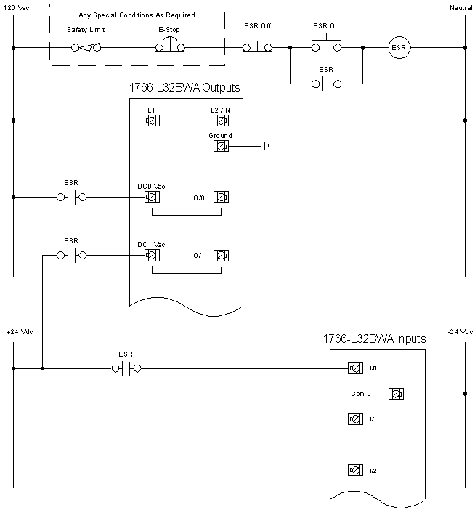

In the Emergency Stop Circuit above the key component is the Emergency Stop Relay. At a minimum this circuit will have a relay with the appropriate number of poles, a N.C. momentary contact push button and a N.O. momentary contact push button. These components are wired to form a simple three wire holding circuit.

In the Emergency Stop Circuit above, what voltage will be on Output 0 when it’s energized? Why will it be this voltage?

Q10.
______________________________________________________________________

______________________________________________________________________

What voltage will be on Output 1 when it’s energized? Why will it be this voltage?

Q11.
______________________________________________________________________

______________________________________________________________________

What Input will be on when the ESR is energized and what will the voltage be?

Q12.
______________________________________________________________________

______________________________________________________________________

If a customer has a high temperature switch that opens on temperature rise and wants it to shut off the PLC outputs where would it go in the circuit?

Q13.
______________________________________________________________________

______________________________________________________________________

Q14. Draft a 120 Vac only Emergency Stop Circuit that uses the high temperature switch described above as it’s only special condition. The inputs are also 120Vac.

